Lab Task

**Task 1:**  (Run C++ Program)

1) Move to Desktop

2) Create new folder “Home”

3) Move to the folder “Home”

4) Create a file “test.cpp”

5) Create an “input.txt” file in Home Directory and write some data in it.

6) Write a simple program that reads a text file “input.txt” and add space after

removing non-Alphabetic characters and copy text in “output.txt” file.

7) Execute program using “g++” command

8) Read the ‘input.txt’ file and read integers from it and find the maximum value

between them and print on the screen.

The contents of input.txt are;

12 ABC43DEF56YTRDFT673221WEBGH3245

The output.txt file contents are:

12 43 56 67 32 21 32 45

Use either c++ or c to program. Create your own text file

Task 2:

Create 3 files

* main.c
* functions.c
* header.h

header.h file contains following function prototypes

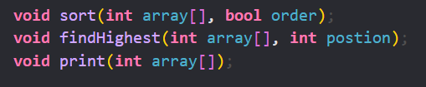

functions.c file contains following 3 functions along with their logic

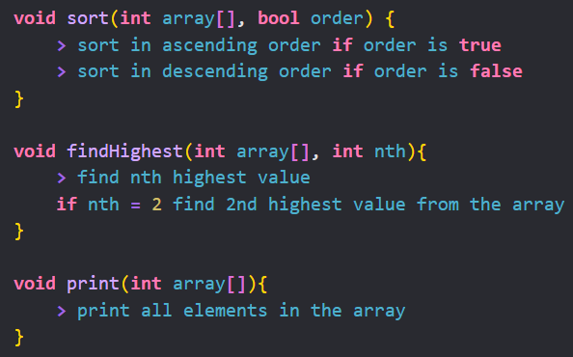

In main.c you will accept command line arguments including 3 things

* an array of integers
* order of sort (1 for ascending order and 0 for descending order)
* nth position to get the nth highest number from the array

Use makefile to execute all these files. Your makefile will look like this.

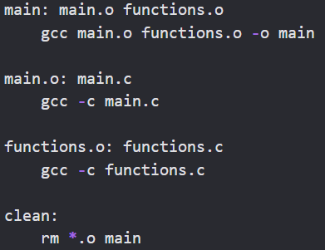

**Example:**

Input: ./main 11 15 13 12 16 14 18 19 20 17 1 4

Output:

